Economic Concepts

* “rational” thinking that you may be familiar with is not the best logical thing in economics
* Economics is about solving the fundamental problem: we have limited resources, but unlimited needs/wants
* Opportunity cost: when you make a decision, you gave up something
* Scarcity: when needs and wants exceed available resources
* Utility: benefits gained from consumption
* Marginal: extra
* Efficient: using all resources
  + Never reached in real life
* If you improve something, something else would degrade
* Graduated: there are different levels
* Progressive: increasing at some rate
* Tax
  + Not all income tax is taxable
  + Each bracket is taxed the same
    - Ex: your first up to $9700 taxed 10%, your next up to $29774 is taxed 12%, etc.
    - This way, your rate doesn’t go up just because your employer gave you an extra dollar and pushed you to another bracket
* Price: amount buyer pays
* Cost:7 amount seller pays
* Trade-off: a choice to be made
* Goods: physical objects that satisfy needs and wants
  + Consumer goods: created for direct consumption
    - Ex: water bottle
  + Capital goods: for indirect consumption. Used to make other goods or deliver services
    - Ex: factory machine
* Services: actions and activities that satisfy someone’s needs and wants
* Factors of production
  + Goods and services require resources:
  + Land: natural resources
    - Oil is involved with everything
  + Labor: effort devoted from a person
  + Capital
    - Physical capital: capital goods
    - Human capital: skills
  + Entrepreneurship: a person who brings the factors of production together
* Production Possibilities Curve
  + A graphical model that demonstrates scarcity, trade-offs, efficiency and opportunity cost
  + Shows alternative ways the economy can use its scarce resources
  + Shows the combinations of goods that can be produced given max efficiency
  + 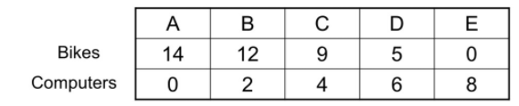
  + 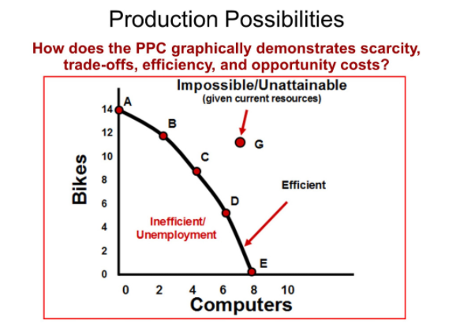
  + All points on the curve are efficient, as that’s where all resources are put in to produce something
  + Only trade will allow us to consume above the curve
  + Tradeoff: producing more of one thing means producing less of another thing
  + Per unit opportunity cost
    - Calculated for moving from one combination to another
    - For each additional (marginal) unit of something gained, how many units of something else was lost (opportunity cost)
    - Marginal opportunity cost: units lost / units gained
    - Ex: going from 12 bikes + 2 computers to 9 bikes + 4 computers, 3 bikes were lost and 2 computers were gained, so for each additional computer produced, 3/2 fewer bikes can be produced
      * 1.5 bikes lost per 1 computer gained
    - Law of Increasing Opportunity Costs: If the per-unit opportunity cost increases as the production of one thing increases, then that means that the resources present aren’t very optimal for producing that thing
      * Curved PPC
  + Economic growth: PPC shifts upwards; more goods can be produced, due to more resources available, or technological innovations
* Trade
  + 2 PPC, one for each country, same goods on the corresponding axis
  + Trade PPC is linear
  + absolute advantage
    - Variable output: which country can produce more
    - Variable input: which country can produce using fewer resources
  + comparative advantage: who can produce at the lowest opportunity cost
    - Let’s say there’s PCC for wine and cloth. If country A has a lower opportunity cost for wine than country B, then country A would export wine, and country B would import wine
    - If both countries input the same amount of resources but output different amounts of goods, then the opportunity cost is calculated using per unit opportunity cost
    - If both countries output the same amount of goods but input different amounts of resources, then the opportunity cost would be (resources needed to produce x / resources needed to produce y)
    - Range of price
      * If it costs country A 0.6 cloth to produce 1 wine, and it costs country B 1 cloth to produce 1 wine, then country B would give country A between 0.6-1 cloth per unit of wine
* Demand
  + Graph: price per unit on the y-axis, number of units sold on the x-axis
    - Represents a competitive market (a group of producers and consumers, and has competitors)
    - Made from the horizontal sum of individual demand graphs
    - A negatively trended graph

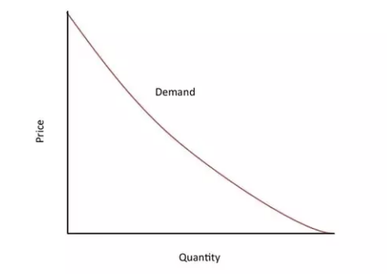

* + The curve is downward sloping because
    - Substitution effect: as the price of one good increases, the more people shift to another good
    - Law of diminishing marginal utility: every time you consume the same good, the less satisfaction you get from it
    - Income effect: the lower the price, the more financially accessible something becomes
  + Demand shock: when demand increases (graph shift right) or decrease (graph shift left)
    - Change in taste
    - Change in price of related goods (complements, substitutes)
    - Change in income
    - Change in the number of buyers, demographics
    - Change in expectations
  + Quantity demand shift: point movement along the demand curve
    - Result of price change
* Supply
  + Graph: y-axis is the price per unit, the x-axis is units available
  + Positively sloped curve
  + 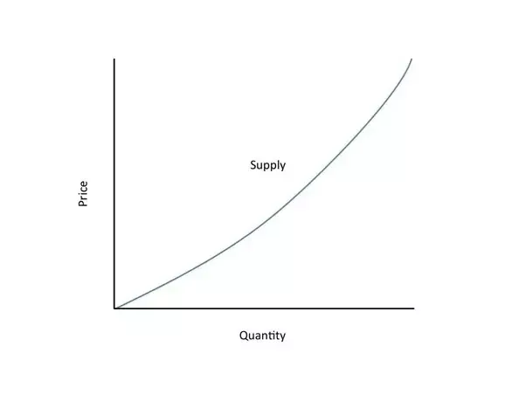
  + The curve trends upwards because
    - Profit effect: if the price goes up, the producer would want to make more to get more profit
    - Increasing opportunity cost: when producing more of something, more inefficiencies are faced. Increasing the price when more is made compensates for this.
  + Reasons for a possible supply shock
    - Change in price of inputs
    - Change in technology
    - Change in the number of sellers
    - Change in future expectations
    - Change in taxes and subsidies
* Supply and demand
  + On a graph, where supply and demand curves intersect is equilibrium
    - That’s the price and quantity that the supplier should produce to meet all demand with no excess
    - Equilibrium changes when supply and/or demand shifts
* Trade and tariffs
  + Tariffs are import tax. Usually, the consumers end up paying for this
  + On a supply and demand graph, trade would be represented by a world supply line that has infinite supply at a low price. (horizontal line at a low price)
  + The intersection between world supply and domestic supply lines is the amount of domestic production we can decrease down to thanks to trade
  + The intersection between world supply and domestic demand lines is the new price and quantity of goods consumers can enjoy thanks to trade
  + Tariff shifts up the world supply line to a higher price
    - The domestic production would need to increase, the price at which consumers can buy goods increase, and the number of goods available decreases
    - The area of the rectangle (see below): tariff price \* number of imported goods = revenue domestic government makes from that tariff
    - The triangle parts of the trapezoid containing the tariff revenue rectangle are deadweight lost: a cost that society is burdened with due to inefficient allocation of resources
      * In this case, the inefficiency comes from tariff causing trade that could’ve happened end up not happening
      * Economists hate tariffs, as open trade allows everyone to be better off
  + 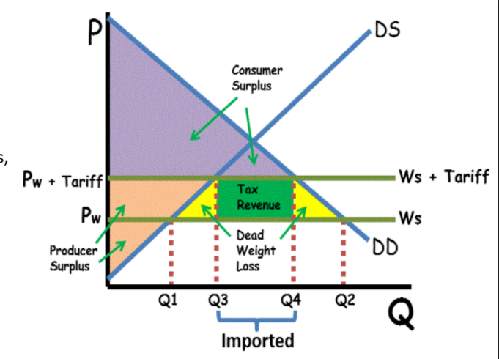

Economic Indicators and Business Cycle

* Macroeconomics
  + the study of the economy as a whole, not business to business
  + This resulted from the Great Depression because there was a lot of unemployment then, and economists didn’t know what to do. We needed a way to measure and fix economic health
  + Goals: stabilize prices (limit inflation - not remove or else people would save too much money and stagnate the economy), promote economic growth, and limit unemployment (not remove because some unemployment means there’s trust in the job market)
* National Income Accounting: a collection of economic data
* Gross Domestic Production
  + The main measure of economic growth. Measures productivity
  + The dollar value of all final goods and services produced in a country during a year
    - The dollar is the unit regardless of country
    - Final means reached end-user for direct consumption. So that intermediate goods (ex: a package of resistors for a computer) don’t get counted multiple times before it reaches the end-user
    - In a country refers to factory location
  + Reported quarterly
  + GDP can be used to compare year to year economic growth, compare other countries, check if a policy works
  + Ways to calculate
    - Expenditure: add all spending on final goods and services in a year
    - Income: add all income gained from the sale of final goods and services in a year
    - 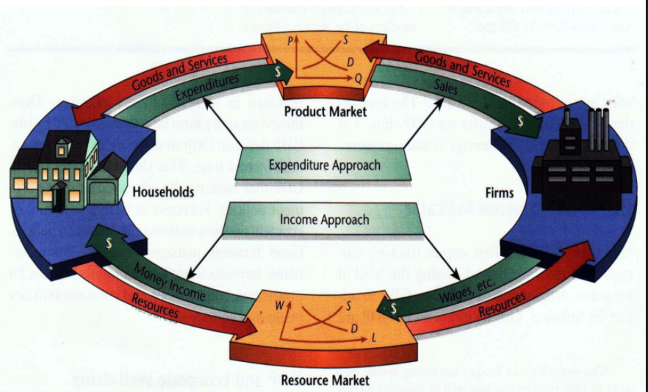
  + Composed of
    - Basically, anything that results in a productive transaction (a brand new good/service gets given to someone to directly consume)
    - Consumer spending
    - Investments
      * Not stock market investments, but capital investments (company spend money to improve themselves)
    - Government spending
    - Net exports
      * Export - import
  + Not composed of
    - Transfer payments
      * Stuff like Social Security, tax
    - Non-productive transactions
      * Ex: stocks, bonds, real estate, used goods
    - Intermediate goods
    - Non-market (illegal activity or informal activities)
      * Ex: drugs, neighbor babysitting
  + Types of GDP
    - Nominal GDP
      * Sum the (price at the time of sale \* number sold) for each good in a year
    - Real GDP
      * Adjusts prices for inflation, making this good for year to year comparisons
      * Uses a base year
      * Sum the (price at base year \* number sold) for each good in a year
    - GDP per Capita
      * Divide nominal GDP by the number of people in a country
      * Good for country to country comparisons
    - Real GDP per Capita
      * Divide real GDP by the number of people in a country
  + GDP deflator
    - Nominal GDP / Real GDP \* 100
    - No units
    - Percent change (as %) of GDP deflator can be used to show the rate of inflation as experienced by the GDP
      * If no previous year data is present, the percent change is N/A
  + Growth rate
    - Use percent change formula on Real GDP
    - Shows growth rate of the economy
  + Limitations
    - Not a good indicator for standard of living, as expenses due to crime, health, etc. also contribute to GDP
    - GDP deflator is only how the GDP experiences inflation, which bundles consumers with government spending, etc
* Unemployment
  + Working age population: a person who is at least 16 years old, not in military nor in prison
    - Labor force: those in the working age population who’s either employed or unemployed
      * Employed: has a legal job
      * Unemployed: doesn’t have a legal job but is actively looking for one
  + Unemployment rate = 100 \* (# unemployed / # in labor force)
  + Labor force participation = 100 \* (# in labor force / # in working age population)
  + Types of unemployment
    - Frictional
      * Person who is qualified for a job, but temporarily not working due to being between jobs
      * Ex: someone who quits a job for another one
      * Seasonal unemployment: a type of frictional unemployment where the frictional unemployment comes from their type of job paired with the current season
        + Ex: a santa impersonator may be frictionally unemployed during the summer
    - Structural
      * Person unemployed due to their skills going obsolete, and will remain unemployed until they develop new skills
      * Ex: VCR is no longer common anymore, so a VCR repairer may be structurally unemployed
      * “Creative destruction”
      * Technological unemployment: a type of structural unemployment where a job gets replaced with robots/automation
        + Ex: factory worker
    - Cyclical
      * The bad kind of unemployment
      * Person unemployed due to economic downturn. The employer wants to keep the employee, but demands for that employee is too low to worth it
      * Ex: A person getting laid off due to the COVID-19 pandemic causing a company to have barely have demands
  + Natural rate of unemployment
    - Sum of frictional + structural unemployment
    - Unavoidable and is desirable
    - Any deviation from this is a result of cyclical unemployment
    - Full employment: unemployment is exactly at the natural rate of unemployment. There is no cyclical unemployment. Anyone seeking a job is capable of finding one
    - Okun’s Law: for every 1% of unemployment that exceeds natural unemployment rate, the GDP goes down 2%
    - Natural unemployment rate is lower in the US than Europe because US unemployment benefits last one year, while in Europe, it’s unlimited, so Americans are more pressured to find a job quickly
  + Limitations of unemployment as an indicator
    - Part time workers who are underemployed (those who want to be full time but can’t) are still considered employed
    - Discouraged job seekers and illegal labor aren’t considered
* Inflation
  + The value of currency decreases; has less purchasing power
  + Prices of goods and services generally rises
  + Disinflation: inflation at a decreasing rate
  + Helps
    - borrowers, as the real value of the debt decreases
    - The economy, as people will spend their money and not cause money circulation to go stagnant
    - Business where price of products increase faster than the price of resources
  + Hurts
    - lenders, as the real value of the currency they get back is decreased
    - Those saving money
    - Those with fixed incomes
      * Costs of Living Adjustments negotiated by a union can counter this
  + Causes
    - Cost push inflation: caused by an increase in the price of inputs of production (aggregate supply shifts left)
    - Demand pull inflation: caused by excess demand (aggregate demand shifts right)
  + Issues
    - Rate of change: price of goods rise faster than the price of labor
      * Things like sticky wages, means a paycheck would be slow to rise when the cost of living rises
    - Unexpected inflation: plans are usually made based on the projected inflation rates
  + Costs associated with inflation
    - Shoe leather cost: value in currency is a use it or lose it thing, while goods have stable value, so there’s a pressure to convert currency to goods
    - Menu cost: labor is needed to update menus to reflect new prices
    - Unit of account costs: people lose trust in contracts when currency, volatile in nature, is a unit of measurement
  + Consumer price index
    - Measures the impact of inflation on consumers
    - Market basket: the cost to buy all the goods a typical consumer would buy in a year
    - A base year and market basket is set
    - CPI is 100 \* (cost of market basket in current year / cost of market basket in base year)
    - Limitations
      * Substitution bias: as prices increase, consumers may switch to substitute products, which wouldn’t be a part of the market basket
      * New products may not be part of the market basket
      * Product quality isn’t accounted for in CPI
  + Real interest rate = nominal interest rate - inflation rate
* Business Cycle
  + 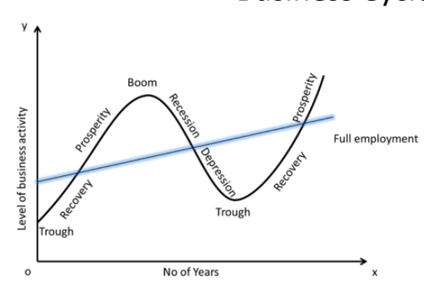
  + Recession is 2 consecutive quarters of GDP decline
* Marginal propensity to consume
  + MPC: proportion of aggregate raise in pay that is spent on the consumption of goods and services instead of being saved (if incomes were raised, how much of that extra income gets spent)
  + Marginal propensity to save = 1-MPC =
  + Multiplier effect: a change in economic activity will end up having a proportionally greater impact on the economy than the initial change
  + Consumption multiplier
    - When a consumer buys something, the money that the consumer spent to buy that thing will become someone’s income. That person will then use some of their income to buy something, and that spending becomes someone’s income, and this cycle keeps going until that money is all saved somewhere. This ends up increasing the GDP by an amount greater than the initial spending
    - Multiplier =
    - Multiply the multiplier to the initial spending to calculate that spending’s potential impact on GDP due to the multiplier effect
  + Consumption function
    - 
    - X-axis is disposable income (income - tax)
    - Y-axis is consumer spending
    - The y-intercept is essential living expenses
    - The slope is the MPC
    - The first derivative approaches 0 as x approaches infinity because once you’re super rich, extra money is like pocket change and isn’t going anywhere
    - The function may shift up or down due to change in real wealth (affected by price levels and stock/bond prices), as well as expectations

National Income and Price Determination

* Aggregate supply and demand
  + x axis is real GDP “output” and the y axis is the GDP deflator “price level”
  + Aggregate demand
    - It’s the total spending at different price levels, so its formula is GDP formula
    - negatively trended just like the demand curve for a competitive market, as it’s just the sum of all of them
    - Reasons for this trend
      * Wealth effect: as the price level increases (inflation increase), the purchasing power of money falls, so buyers become poorer and buy less
      * Interest rate effect: as price level increases, there would be more demand for borrowing money, so interest rates would increase, deterring interest sensitive spending
    - Reasons why aggregate demand can shift
      * Left for decrease, right for increase
      * Since aggregate demand formula is basically GDP formula, anything that changes GDP will shift the aggregate demand
      * Change in expectations and change in wealth
      * Inventory: companies plan for investments, but planning can be off. If the planning overforecasted, inventory would build up, so the company would decrease its spendings, to allow surplus to be eaten up
      * Government fiscal policies
        + Controlled by Congress and White House
        + Transfer payments, taxes, government spending
      * Government monetary policy: Federal Reserve Bank manipulation of the money supply
        + More money = more spending
  + Aggregate supply
    - Short Run
      * 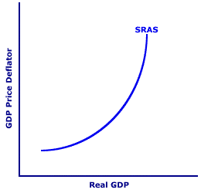
      * Positively sloped like the supply curve in a competitive market, since it’s just the sum of them
      * Reason for positive slope
        + Profit incentive: If the supplier could make more money from selling something, they would make more
        + Wages usually remain sticky in the short run, so an increase in price level does result in more profit in the short run
      * Ways aggregate supply can shift
        + Change in price of inputs
        + Change in nominal wage
        + Change in productivity
    - Long run
      * 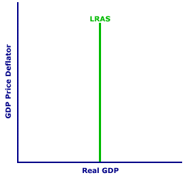
      * Wages (greatest price in production) are only sticky in the short run, so in the long run, a profit incentive doesn’t exist, so output remains the same in the long run regardless of price level
      * LRAS represents an economy’s output potential
      * Can be shifted by
        + Change in quantity and quality of resources
        + Technological advancements
  + Shocks
    - Supply shock
      * Events that shift short run aggregate supply
      * Stagflation: a negatively shifting supply shock that causes equilibrium to be below potential output
      * Growth: a positively shifting supply shock that causes equilibrium to be above potential output
    - Demand shock
      * Events that shift the aggregate demand
      * Recessionary shock: a negatively shifting shock that causes equilibrium to be below potential output
      * Inflationary shock: a positively shifting shock that causes equilibrium to be above potential output
  + A vanilla graph
    - 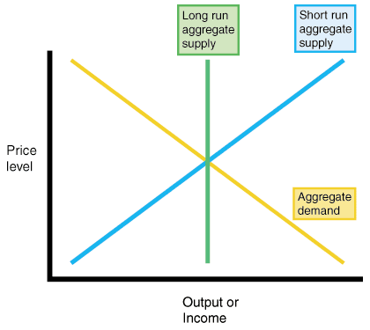
    - “Vanilla” has equilibrium right at the potential output
    - When shifting curves, use this as starting point
  + The economy is self-correcting in the long run
    - Economy brings its equilibrium back to being on full potential output in the long run
    - Recovering from a recessionary shock: a recessionary shock will lower price level, so wages will fall in the long run. Falling wages will cause a growth shock, which would bring equilibrium back to full potential output, but at a lower price level than before
    - Recovering from an inflation shock: an inflationary shock will increase price level, so wages would rise in the long run. Rising wages would cause a stagflation shock, which would bring equilibrium back to full potential, but at a higher price level than before
* Discretionary Fiscal Policy
  + Policies controlled by Congress to smooth out the business cycle
  + Direct policy: government spending
    - Effect on GDP: spending multiplier of
  + Indirect policy: taxes and transfer payments
    - Indirect because impact on GDP is not a direct result of a government’s action; these policies give the people more disposable income, which will cause the people, not the government, to affect the GDP
    - Effect on GDP
      * The government spends money on this, so people get money, but the people receiving the money isn’t going to spend all the money; people spend some save some
      * To find the amount of money the government spends on indirect policy that actually gets spent by consumers: multiply change in tax or transfer payment by the MPC
      * Use that product to multiply to the spending multiplier to get effect on GDP
      * (or, use the tax multiplier: MPC / MPS)
  + Flaws
    - Leakage: money spent on internationally imported goods, as well as informal markets aren’t counted in GDP
    - Lag
      * Information lag: time between when the economy changes and when we realize a change happened
      * Policy lag: time between when the change is realized and when new policy is implemented
      * Impact lag: time between when new policy is implemented and action finally carries out and create an effect on the economy
      * This is why Automatic Fiscal Policy (Automatic Stabilizers) exist
* Automatic Fiscal Policy
  + Pre-created policies that automatically adjust based on current economic trends

Financial Sector

* Financial intermediary
  + Pools money together and bridges different groups together
  + Bank
    - bridge the savers and the borrowers
    - All investment spendings come from savings, whether it’s the investor’s own savings, or as loans where they borrow from other people’s savings
    - Banks in a nutshell: people can deposit money into them, and people that the bank trusts as reliable can borrow that money.
    - Deposit Insurance: the FDIC insures $250,000 per account, in case the bank is unable to give you your deposits
    - commercial banks: FDIC insured, provides services (checking accounts and loans) to businesses and individuals
    - Investment bank: trading financial assets; not FDIC insured
    - Discount window: the FED loans money to banks overnight
    - Reserve requirements: the FED requires banks to have a certain percentage (reserve ratio) of your deposits on hand
      * Deposit multiplier effect: someone deposits money. Another person borrows some of that money. That creates new money. The money that second person borrowed could get deposited, and the cycle continues, creating more new money
      * Multiplier: 1 / reserve ratio
      * amount of money a bank can loan \* deposit multiplier = total potential amount of money added to money supply
    - Capital requirements: the amount of cash and liquid assets a bank must have on hand, calculated as a percentage of assets it has
  + Mutual funds
    - Bridges investors to stockbrokers
    - mutual funds buy a bunch of stocks to form a stock portfolio
    - Investors get a portion of the portfolio
  + Pensions
    - Bridges workers to retirees
    - Workers put in a portion of their income
    - Retirees get money to use
  + insurance companies
    - Bridges people that need some money right now for something to those that don’t
    - Ex: everyone pools in some money for people who need to pay for a car repair
  + Tasks of a financial intermediary
    - Reducing transaction costs
      * lowering the expense of putting a deal together
      * A bank has access to a lot of people’s savings, so a deal would only involve 2 parties, saving cost
    - Reduce risk
      * Spread risk over many people and diversifying, so if a few venture fails, the people who deposited money are still safe
      * Verify borrowers’ ability to repay
    - Provide liquidity
      * The ease in which an asset can be used to pay a debt while keeping its value
      * Cash is the most liquid asset
      * How a bank can turn things more liquid: let's say you want to settle a debt. You have a house. Giving away your house to settle debt means giving away something of a lot of value to you, but not as much value to the other person. You can give a portion of the value of your house to the bank in exchange for cash, which you can use to settle your debt
* Financial Assets
  + Loans
    - An agreement between a borrower and a lender
    - It’s an asset to the loaner
    - It’s a liability to the borrower
  + Bond
    - A type of loan
    - When buying a bond, the purchaser is loaning money to the seller
    - Maturity: the length of time before the par value is returned to the purchaser
    - Par value: the worth of the bond at maturity
    - Coupon: a fixed interest rate of the bond
      * The riskier the borrower, the higher the coupon
    - May be bought and sold in a secondary market (reselling)
      * The price a bond sells at will fall as interests rates go up, since coupons are fixed and won’t rise with the rising interest rate
      * Yield
        + Percentage of the price you paid that you get back each month
        + Nominal yield: bond coupon
        + Current yield: based on current price of bond and coupon amount

(coupon amount / price) as percentage

* + - * + Yield to maturity: considers current market price, coupon rate and time to maturity
      * The bond buyer would want a higher yield, to get more money faster
      * The bond owner would want higher prices, since the coupon is fixed, so raising price is how the owner would profit
    - Types
      * Corporate bonds issued by companies
      * Municipal bonds issued by municipalities
      * US Treasury bonds (T-bond) issued by the US government
  + Loan-backed securities
    - Loans are pooled together and sliced up and resold
  + Stocks
    - A security that signifies the ownership of a corporation
    - Claiming a part of that corporation’s assets and earnings
    - Common stock: holders are entitled to vote and get dividends
    - Preferred stock: no voting, but higher claim on assets and earnings
  + Money
    - An medium that can easily be used to exchange for goods and services
    - Enables transactions without bartering
    - Store of value: holds purchasing power over time
    - Unit of account: something used to make economic calculations and set prices
    - Types:
      * Commodity money: money that’s also a good
      * Commodity backed money: money that can be converted back into the commodity backing it
      * Fiat money: money that government made into an official means of exchange
    - Money supply
      * M0: all coins and currency
      * M1: M0 + checking accounts/debit cards and traveler checks
      * M2: M1 = small savings accounts, money market accounts and small deposits
      * M3: M2 + large time deposits, stocks, bonds, mutual funds
    - Money market
      * 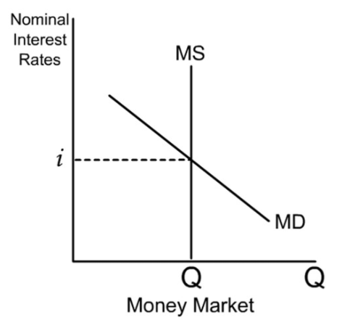
      * X axis is the amount of M1 in the market
      * Y axis is the nominal interest rate
      * The supply line for the supply of M1 is vertical because it is managed by the FED
        + Shifts by the FED adjusting the money supply
      * The demand line for M1 is about the people’s demand for keeping their money as M1, rather than M2
        + Is negatively sloped because the higher the interest rate, the more worth it to store it as M2. The lower the interest rate, the more worth it to just have it as M1 (more liquid) as interest rates isn’t going to do much
        + Can shift

Demand increases when inflation increases, as more money on hand would be needed

Higher GDP would increase the demand for M1, as people would buy more things

Financial tech advancements would decrease the demand for M1, as M2 become more liquid

Regulatory changes to how M1 and M2 are treated will affect the demand for M1

* + - * Intersection point would indicate the equilibrium nominal interest rate
* Federal Reserve
  + Protects economic health by ensuring high levels of employment and preserving the purchasing power of the dollar
  + Regulates and provides services to banks
  + Independent from politics
  + Conducts monetary policy
    - Controls how much money is floating around
    - Open market operations: the FED buys and sells T-bonds to banks to affect their reserves to affect their loans
      * The FED buying T-bonds increases the money supply
      * The FED selling T-bonds decreases the money supply
    - Discount rate: the rate for banks to borrow money from the FED
    - Federal funds rate: rate for interbank lending to affect interest rate
      * The FED can only influence this, not directly set it
      * The FED buying T-bonds decreases this rate, which may decrease interest rates
      * The FED selling T-bonds increases this rate, which may increase interest rates
    - The FED can also set the reserve ratio, which would affect the money supply. However, the FED rarely exercises this option.
* T-Accounts
  + A balance sheet for banks to track their money
  + One side is for assets (own), while the other is for liabilities (owe)
  + Both sides must equal each other
  + Scenarios
    - The owner of the bank puts money into it
      * Assets: Some of that money may go to equipments, while the rest may go into reserves
      * Liabilities: The bank owes the owner owner equity
    - A customer deposits money into the bank
      * Assets: (deposit amount \* reserve ratio) amount of money goes into required reserves. The rest of the money goes into excess reserves
      * Liabilities: The customer may want their money back eventually (demand deposits)
    - Someone takes out a loan from the bank
      * Assets: Money from the excess reserves can be turned into loans
    - A customer withdraws money from the bank
      * Assets: (deposit amount \* reserve ratio) amount of money comes out of required reserves. The rest comes out of excess reserves.
        + If there isn’t enough money in the excess reserves, take from the required reserves, then borrow from another bank/FED to cover.
      * Liabilities: demand deposits decrease the withdrawn amount
    - The FED does open market operations
      * FED selling
        + Assets: some money from excess reserves become securities
      * FED buying
        + Assets: some money from securities become excess reserves
    - Bank borrows money from another bank or the FED
      * Asset: gains excess reserves
      * Liabilities: gains borrowings
* Loanable funds market
  + Supplier: savers
  + Demand: borrowers
  + Like the standard supply and demand graph
  + X axis is amount of loanable funds
  + Y axis is the real interest rate
  + Negative sloping demand graph because loans with higher interest rates are less attractive
  + Positive sloping supply graph because of profit incentives for the loaner side
  + Intersection is equilibrium for the amount of loanable funds on the market, and interest rate
  + Businesses tends to only borrow when the rate of return is greater than the rate of interest
    - (revenue - cost) / cost
  + Demand curve shifts
    - If future opportunities are perceived to increase, then demand increases
    - Following change in government borrowings
  + Supply curve shifts
    - Following change in private savings behavior
    - Following change in investors’ perceived safety of their money
  + Real interest rate = nominal interest rate - inflation rate
  + In the short run, a decrease in interest rate leads to an increase in GDP, which leads to an increase in savings, which leads to an increase in loanable funds
  + In the long run, the money market has no impact on the loanable funds market because price level will eventually catch up with the money supply, neutralizing the money market’s effect on loanable funds
  + Crowding out effect
    - Government borrowing money will cause real interest rates to increase, therefore decreasing the quantity of money demanded by private borrowers
    - View 1:
      * 
      * Once government borrowing is added, the demand curve shifts right, causing the real interest rate to rise. At the higher real interest rate, the private demand for loanable funds decreases
    - View 2:
      * When government starts borrowing money, some people will have to choose to lend money to the government instead of private borrowers

Long-Run Consequences of Stabilization Policies

* Phillips curve
  + 
  + Movement along the short run Phillips curve
    - Result of a demand shock
    - If a positive demand shock happened, on the AD/AS graph, you would see that the price level went up (inflation went up) and GDP went up (unemployment went down). This means the economy has moved up the SRPC
      * This is also why the SRPC is negatively sloped
    - Conversely, a negative demand shock would move the economy down the SRPC
  + Shifts of the short run Phillips curve
    - Result of a supply shock
    - If a negative supply shock happened, on the AD/AS graph, you would see that price level went up (inflation went up) and GDP went down (unemployment went up). This means that the SRPC has shifted to the right, and the economy has moved diagonally from the old SRPC to the new SRPC.
    - Conversely, a positive supply shock would shift the SRPC to the left
    - Expected inflation is also a shifter
      * If inflation is expected to increase, the SRPC would shift to the right, in a 1:1 ratio
      * If inflation is expected to decrease, the SRPC would shift to the left, in a 1:1 ratio
  + Since the economy is self-recovering in the long run, the LRPC is vertical
    - No long term tradeoff exists between unemployment and inflation
    - The vertical is on the natural rate of unemployment
    - Price Wage Spiral: inflation can cause more inflation
      * Inflation means wages increase in the long run, which would enable more spending, which would cause more inflation, which would cause wages to increase, and so on
      * An unemployment rate less than the natural rate of unemployment would accelerate inflation
      * An unemployment rate greater than the natural rate of unemployment would decelerate inflation
* Economic theories
  + Classic Economic Theory: the economy is self-recovering; do not touch it
  + Keynesian: prices and wages do not like to fall, which is required in order for the economy to self-recover. As a result, depending on the Classic Economic Theory would mean long wait times, which means a long, unnecessary period of pain to citizens. The government can shorten the wait time by stepping in with fiscal policy.
  + Monetarist Theory
    - Velocity of money
      * Remember the multiplier effect? The velocity is how many times the average dollar gets spent on final goods and services
      * MV=PQ
      * M is the money supply
      * V is the velocity
      * P is the average price of goods
      * Q is the quantity of goods
      * PQ collectively is the GDP
    - Government fiscal policy creates financial instability
    - In an economical emergency, monetary policy can be helpful in accordance to the velocity of money

Open Economy

* Balance of payment
  + A summary of a country’s transactions with the world
  + Has two columns: one for debit (money leaving the country), and credit (money entering the country)
  + Ways to get debt/credit
    - Current account
      * Sales of goods and services
      * Factor income: money from an asset owned in another country
      * Transfer payment: money from a resident of one country to another
    - Capital account: sale/purchase of assets
  + The credit should cancel out the debit
* Exchange rate
  + Exchange rates of foreign currency is based on a supply and demand graph of the 2 countries’ currencies
  + 
  + The vertical axis is the exchange rate
  + How to shift: if country 1 wants to buy goods from country 2, then the demand for currency 2 increases, and the supply of currency 1 increases. As a result, the equilibrium price of currency 1 decreased and the equilibrium price of currency 2 increased, so currency 2 appreciated, and currency 1 depreciated
    - When currency 1 depreciates, country 1’s consumers are on the losing end, as foreign goods become more expensive for them. Country 1’s producers are on the winning end, as the goods they export would appear cheaper, attracting foreign demand.
  + Shifters
    - Consumer tastes: whether a country’s residents like foreign goods
    - Relative income: if people have more income, they would buy more things, including foreign goods
    - Relative inflation: higher inflation rates means higher returns on investments, which would attract foreign investments
    - Speculations: people profiting from buying/selling currencies
  + Purchasing power parity
    - How equal domestic purchasing power is when exchange rates are at equilibrium
    - Ex: if 1 USD = 2 euros, then does a soda that costs $1 in the US cost 2 euro in euro countries?
    - Parity is reached in the long run
    - Big Mac Index: tracking purchasing power parity by checking the prices of McDonald’s Big Macs around the world
    - Problems
      * Travel costs: the differing costs involved in transporting goods to different parts of the world aren’t considered
      * Perishability: doesn’t account for the costs involved with goods being perished while in transit to different places
      * Location: GDP differences
      * Labor cost: doesn’t account for the difference in employee protection laws around the world
  + Exchange rate policy
    - Fixed exchange rate: a government can choose to fix the exchange rate to that of another currency
      * Ex: Belizian government chose to fix the Belizian dollar to the USD, so that 1 USD will always equal 2 Belizean dollar
      * Achieved through the government manipulating the exchange rate to make it reach target
    - Fluctuating exchange rate: the government can choose to let the market determine the exchange rate
    - The government manipulating the exchange rate
      * Exchange market operation: selling foreign currency can appreciate its own currency
      * Monetary policy: increasing interest rates can appreciate its own currency
      * Foreign exchange control: limiting the amount of currency allowed to leave the country can appreciate its currency